A Turing machine M with start state q₀ and accepting state q_{f} has the following transition function:
δ(q, a) | 0 | 1 | B
q₀ | (q₀, 1, R) | (q₁, 1, R) | (q_{f}, B, R)
q₁ | (q₂, 0, L) | (q₂, 1, L) | (q₂, B, L)
q₂ | - | (q₀, 0, R) | -
q_{f} | - | - | -

TURING MACHINE DIAGRAM:
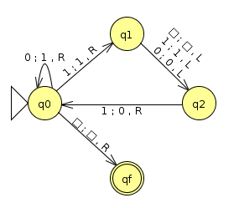Turing machine

SIMULATION RESULT:
When Turing machine M starts in q₀ state at the left end of a sequence of any numbers of 0's (including zero of them) and a 1, all 0's (if exist) are changed to 1 remaining in q₀ state; when 1 is found the state changes to q₁ and the next number whatever it be forces to q₂ state and left moving, pointing again to the first 1, so q₂ always transition to q₀ state changing the 1 to 0 and returning to the beginning. When all input is consumed and first B appears, the state changes to final state q_{f}
A) String: 0011
q₀0011 ⊢ 1q₀011 ⊢ 11q₀11 ⊢ 111q₁1 ⊢ 11q₂11 ⊢ 110q₀1 ⊢ 1101q₁ ⊢ 110q₂1 ⊢ 1100q₀ ⊢ 1100Bq_{f}
B) String: 1010
q₀1010 ⊢ 1q₁010 ⊢ q₂1010 ⊢ 0q₀010 ⊢ 01q₀10 ⊢ 011q₁0 ⊢ 01q₂10 ⊢ 010q₀0 ⊢ 0101q₀ ⊢ 0101Bq_{f}

